**Charge’n’Go – solar powered wristband**

Front Back

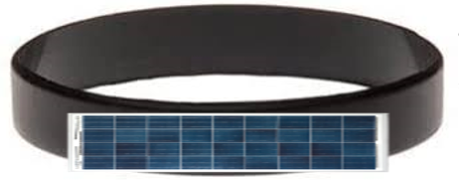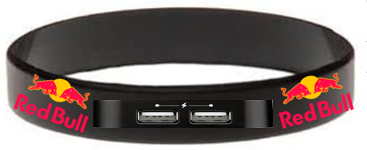

*Description:*

Charge’n’Go is a wristband with a solar panel and two USBs so that multiple devices can charge at once. It is the perfect device for charging your phone on the go. This wristband is durable and can be adjusted for the customers preferences.

*Target audience:*

This product is all-inclusive and therefore can be used by anyone who is looking for an easy way to charge their devices on the go. It is very useful for people who are outside and often away from charging ports.

*Pricing:*

The Charge’n’Go is priced at £14.99. It is one payment for a lifetime full of use. This is great in these troubling times of our energy crisis.

*Justification for product:*

People should buy this product because it is a compact way to carry easy to access energy for charging devices needed in day-to-day life. People can enjoy the sun while making sure their devices stay charged.

*Future developments:*

In the future we may add more solar panels to maximise the amount of solar power that can be acquired. We may also increase the size of the wristband so the area of solar panels can be increased.